MATH 1324 – FINITE MATHEMATICS

POST-CHAPTER 4 CONDITIONAL PROBABILITY, AND BAYES’ THEOREM
- We say two events $E$ and $F$ are independent if the outcome of one does not affect the outcome of the other.
- DO NOT CONFUSE INDEPENDENCE WITH MUTUALLY EXCLUSIVE!!!!
- Test for the Independence: Events $E$ and $F$ are independent if and only if $P(E ∩F) = P(E)P(F)$
- If $E_{1},E_{2},E_{3},…,E_{n}$ are independent events, then $P(E1 ∩E2 ∩E3 ...En) =P(E1)P(E2)P(E3)...P(En)$

- Suppose the probability that the school bus drives by your house before 6:50am on a school day is 0.90. What is the probability that the school bus drives by your house before 6:50am on two consecutive days? three consecutive days?

- What is conditional probability? It is where you know some information, but not enough to get a complete answer. You may know information about an event once another event has happened.
- The conditional probability of event $E$ given event $F$ is $P(E|F) = \frac{P(E ∩F)}{P(F)}$
- Revisiting a previous example: A survey is done of people making purchases at a gas station. Most people buy gas or a drink. The results are shown in the table below.
 | buy drink $(D)$ | no drink $(D^{c})$ | TOTAL
buy gas $(G)$ | 20 | 15 | 35
no gas $(G^{c})$ | 10 | 5 | 15
TOTAL | 30 | 20 | 50
- What is the probability that someone who buys a drink also buys gas? In other words, given a person bought a drink, what is the probability he bought gas? We write $P(G|D)$, which we read as the probability of $G$ given $D$

  - In this case, since we know that the person bought a drink, our sample space is not all 50 people. We have reduced our sample space to just the 30 who bought drinks.

  - Going back to our example, we have $P(G|D) =$

- What is the probability that a person who buys gas does not buy a drink?

- NOTE: $P(E|F) = \frac{P(E ∩F)}{P(F)}$ so $P(E ∩F) = P(F)P(E|F)$
- At a party, $\frac{1}{3}$ of the guests are freshmen. $\frac{3}{4}$ of the freshmen are wearing clothing with a college logo and $\frac{1}{10}$ of the upperclassmen are wearing clothing with a college logo. Draw a tree diagram for this situation.

- NOTE: This situation needs a tree diagram because you only have information about clothing with a college logo once you know the class of the person, i.e. knowledge about clothing with a college logo is conditional on knowledge of class.

- What is the probability that a person chosen at random is wearing clothing with a college logo?

- What is the probability that a person chosen at random is an upperclassman and is wearing clothing with a college logo?

- What is the probability that a person who is a freshman is not wearing clothing with a college logo? (or given freshman, what is the probability he is not wearing clothing with a college logo?)

- I am cleaning up after the party and pick up a sweatshirt with a college logo on it. What is the probability a freshman was wearing it?

- Any time you know the second set of branches and work backwards, you are using Bayes’ Theorem. Think of favorable over total. Write all the paths the given event (on the last set of branches) can occur, starting from the root. This is the total and goes on the bottom. Put the path you want on top.
- A cup contains one red and two green marbles. A bowl contains three red and two green marbles. If you flip heads when flipping a weighted coin that lands heads 75% of the time, you choose a marble from the cup. Otherwise, you choose a marble from the bowl.
  - What is the probability the marble is red?

  - What is the probability the marble came from the bowl if it is red?

  - What is the probability the marble is green if it came from the bowl?

- A department store buys 50% of its appliances from Manufacturer A, 30% from Manufacturer B, and 20% from Manufacturer C. It is estimated that 6% of Manufacturer A’s appliances, 5% of Manufacturer B’s appliances, and 4% of Manufacturer C’s appliances need repair before the warranty expires. An appliance is chosen at random. If the appliance chosen needed repair before the warranty expired, what is the probability that the appliance was manufactured by Manufacturer A?

- Experiment: Cast a pair of fair six-sided dice. What is the probability that

  - one die is a 2 if the sum is 8?

  - the sum is 5 if one die is a 1?
The first number represents the outcome of the first die, and the second number represents the outcome of the second die.
$$S=\left\{\begin{aligned}11, 12, 13, 14, 15, 16, \\ 21, 22, 23, 24, 25, 26, \\ 31, 32, 33, 34, 35, 36, \\ 41, 42, 43, 44, 45, 46, \\ 51, 52, 53, 54, 55, 56, \\ 61, 62, 63, 64, 65, 66\end{aligned}\right\}$$

- Experiment: Box A contains 3 red and 4 blue marbles. Box B contains 6 red and 4 blue marbles. Draw a marble from Box A and transfer it to Box B. Then draw a marble from Box B. What is the probability that
  - a red marble was drawn from Box B?
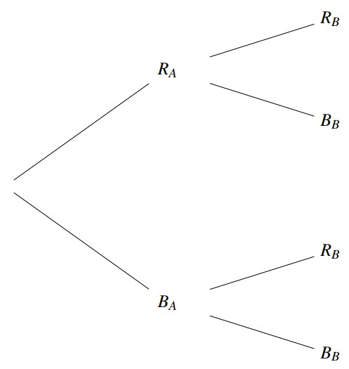

  - a blue marble was drawn from Box B if a blue marble was drawn from Box A?

  - a blue marble was drawn from Box A if a red marble was drawn from Box B?

The following is an example of a stochastic process, in which the probabilities at each stage depend on previous outcomes and probabilities.

- Draw three cards from a standard deck of 52 cards without replacement.
  - What is the probability the three cards are hearts?
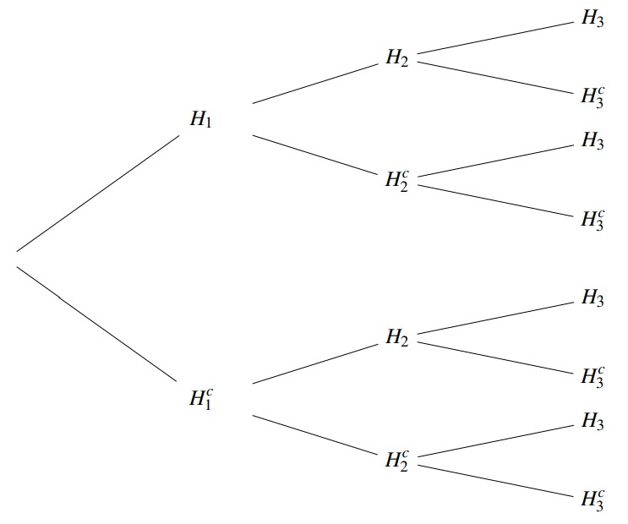

  - Find the probability the third card is a heart.

  - Find the probability the third card is a heart, given the first two are hearts.

