MATH 1324 – FINITE MATHEMATICS

PRE-CHAPTER 4 SETS AND SURVEY PROBLEMS
- Definition: A set is a well-defined collection of objects. Denoted by capital letters. This is not just any collection. It must be defined in such a way that we can determine whether or not an object belongs to the collection.
- Objects of a set are called elements. Usually denoted by lowercase letters.
- Suppose A is the set containing the elements $a,b$, and $c$. We write $A = \{a,b, c\}$
- Suppose $B$ is the set containing all the letters of the English alphabet. We write

- If $a$ is an element of a set $A$, we write $a ∈ A$. If $a$ is not in $A$, we write $a∉A$
- Two sets $A$ and $B$ are equal if and only if they contain the same elements. Written as $A = B$.
- If every element of a set $A$ is also an element of a set $B$, then $A$ is a subset of $B$. We write $A ⊆ B$
- NOTE: Every set $A$ is a subset of itself.
- The set that contains no elements is the empty set or null set. Denoted by $∅$. The empty set is a subset of every set.
- List all subsets of the set $A = \{?,5, k$}

- The set of all elements of interest in a particular situation is the universal set.
- Venn Diagrams

- Intersection of sets $A$ and $B$:
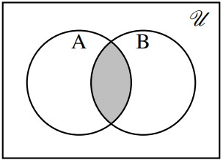
$A∩B=\{x|x∈A and x∈B$}
The set of all elements in both $A$ and $B$.
- Union of sets $A$ and $B$:
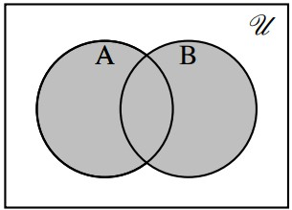
$A∪B=\{x|x∈A, x∈B, and x∈A∩B$}
The set of all elements that belong to either $A$ or $B$ or both

- Let $A = \{2,4,r,7,m,!, k,3\}$, $B = \{5,2, p,r, k,!,8, y\}$. Find

  - $A∪B$
  - $A∩B$

- Let $A = \{1,3,5,7\}$ and $B = \{2,4,6,8,10\}$. Find

  - $A∪B$
  - $A∩B$

- Complement of set A:
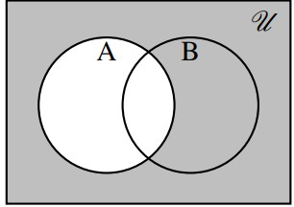
$A=\{x|x∈U and x∉A$}
The set of all elements in $U$ but not in $A$
Disjoint:
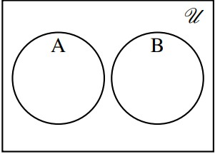
$A∩B=∅$

- Sets $A$ and $B$ are disjoint if they have no elements in common. (If $A∩B = ∅$).

- Suppose $U = \{1,2,3,4,5,6,7,8,9,10\}$ and $A = \{2,3,6,8\}$. Find $A^{c}$ .

- Set Complementation: If $U$ is a universal set and $A$ is a subset of $U$, then

  - $U^{c} =$
  - $$∅^{c}=$$
  - $${\left(A^{c}\right)}^{c}=$$
  - $$A∪ A^{c} =$$
  - $$A∩A^{c}=$$

- Set Operations: Let $U$ be a universal set. If $A,B,C$ are arbitrary subsets of $U$, then

- $A∪B = B∪A$
- $A∩B = B∩A$
- $A∪\left(B∪C\right)= \left(A∪B\right)∪C$
- $A∩(B∩C) = (A∩B)∩C$
- $A∪(B∩C) = (A∪B)∩(A∪C)$
- $A∩(B∪C) = (A∩B)∪(A∩C)$
- De Morgan’s Laws: Let $A$ and $B$ be sets. Then ${\left(A∪B\right)}^{c}=A^{c}∩B^{c}$ and ${\left(A∩B\right)}^{c} = A^{c}∪B^{c}$

- Given the set $X$ below, find
  - $X ∪A^{c}$
  - $\left(X ∪A\right)∪\left(C^{c}∩B\right)$
  - ${\left(X ∪A\right)}^{c}∩B$
  - ${\left(X ∪A\right)}^{c} ∪B$
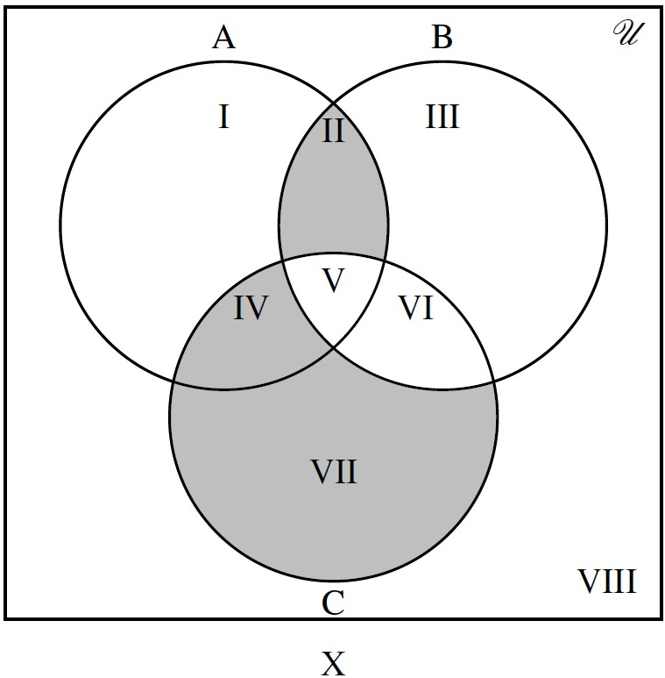
- Problems that call for finding the number of elements in a set are called counting problems. This field of study is called combinatorics.
- The number of elements in a finite set is determined by simply counting the elements in the set.
- If $A$ is a set, $n(A)$ denotes the number of elements in $A$.
- $n(∅) =$
- If $A$ and $B$ are not disjoint sets, then
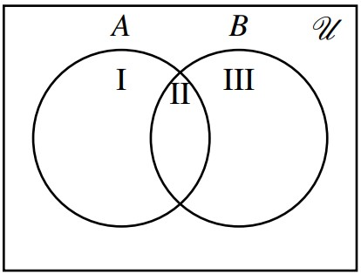
- If $A$ and $B$ are disjoint sets, then

- Suppose $A = \{3,r,a,5,7,*,b, x\}$, $B = \{a, x,5,b, j,8\}$, $C = \{r,a,7\}$, and $D = \{3,b,*\}$. Find

  - $n(A∪B)$
  - $n(C∪D)$

- Among 500 freshmen pursuing a business degree at a university, 320 are enrolled in an economics course, 225 are enrolled in a mathematics course, and 140 are enrolled in both an economics and a math course.

  - How many freshmen from this group are enrolled in an economics or a math course?

  - How many freshmen from this group are enrolled in only an economics course?

  - How many freshmen from this group are enrolled an economics but not a math course?

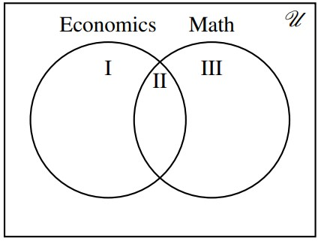

- A survey of 100 teenagers about their hobbies revealed the following:

- 40 play video games
- 9 only play sports
- 25 read novels
- 15 play video games and play sports
- 12 play video games and read novels
- 10 play sports and read novels
- 4 read all three
  - How many teenagers surveyed have at least one of those hobbies?

  - How many teenagers surveyed have exactly one of those hobbies?

  - How many teenagers surveyed have exactly two of those hobbies?

  - How many teenagers surveyed have none of those hobbies?

  - How many teenagers surveyed play video games but do not read novels?

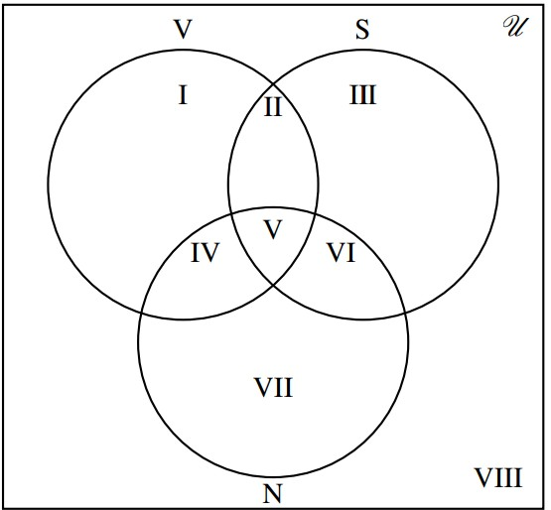

- In a survey of 300 people:
- 122 drink Sprite
- 150 drink Coke
- 62 drink Pepsi
- 38 drink Sprite and Coke
- 20 drink Sprite and Pepsi
- 28 drink Coke and Pepsi 3
- 6 drink none of these.
Fill in the Venn diagram.
