MATH 1324– FINITE MATHEMATICS
SECTION 2.3 SYSTEMS OF TWO EQUATIONS IN TWO UNKNOWNS

Solutions to systems of linear equations
- Given any two lines $L_{1}$ and $L_{2}$ in the Cartesian plane, one and only one of the following may occur:
  - The lines $L_{1}$ and $L_{2}$ intersect at exactly one point. This describes an independent system.
- Solve
$$2x-y=1 \\ 3x+2y=12$$

- $L_{1}$ and $L_{2}$ are parallel and coincident. This describes a dependent system.
- Solve
$$2x-4y=2 \\ 3x-6y=3$$

- $L_{1}$ and $L_{2}$ are parallel and distinct. This describes an inconsistent system.
- Solve
$$5x+20y=10 \\ -3x-12y=8$$

- Given two nonparallel lines $L_{1}$ and $L_{2}$ ($L_{1}:y=m_{1}x+b_{1}, L_{2}:y=m_{2}x+b_{2}$), we can find their point of intersection.
- Find the intersection point of the lines $y = x+1$ and $y = -2x+4$.

- Break-even levels of operation:
  - When revenue received from selling $x$ items exceeds cost, the company __________________________________.
  - When cost exceeds revenue, the company __________________________________.
- Break-even point: the point where

  - This point is the

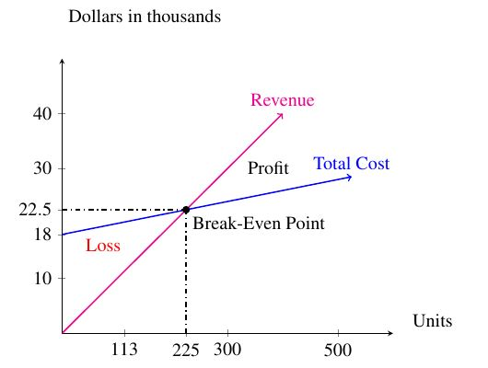

- Consider the graph:
  - How many units must the company produce to break even? What is the revenue earned when the company breaks even?

  - If the company produces and sells 412 units, is a loss incurred or profit earned?

  - Find the revenue function from the graph.
- Revisiting a previous example: Malone Industries produces knitted accessories like scarves, shawls, and hats. For the division that produces knitted hats, each hat sells for $12, and the variable cost of producing each unit is 30% of the selling price. The monthly fixed costs incurred by this division of Malone Industries are $20,000.
  - What is the break-even point for the division?

  - Do you notice any relationship between the x-intercept for the profit function (see Section 2.2) and the break-even quantity?

  - What is the loss sustained by the division if only 1200 units are produced and sold each month?

  - What is the profit earned by the division if 3500 hats are produced and sold each month?

  - Suppose the division of Malone Industries that makes shawls has monthly fixed costs of $35,000. Each shawl costs $15 to make and sells for $48. Find the break-even point for this division of the company.

- Market equilibrium: Achieved when
  - Equilibrium quantity and equilibrium price are found

- Revisiting a previous example (from Section 2.2): A company makes rollerblades. When the unit price is $180, quantity demanded is 10 pairs. Quantity demanded is 50 pairs when the price is $100. The company is not willing to sell rollerblades for $60 or less per pair. It will supply 10 pairs if it can get $80 a pair. What is the equilibrium point for the sale of rollerblades?
- RECALL FROM 2.2: $D(x) = -2x+200$ and $S(x) = 2x+60$

