MATH 1324 – FINITE MATHEMATICS

SECTIONS 3.1-3.3 LINEAR PROGRAMMING PROBLEMS
- Procedure for graphing linear inequalities:
  - Replace the inequality sign with an equal sign.
  - Graph the line. If the original had $≤$ or $≥$, use a solid line. If the original had $<$ or $>$, use a dotted line.
  - Plug a test point into the original inequality. (Use a point on either side of the line, not on the line).
  - Shade the true region.
- The region that satisfies our inequality is called the feasible region, $S$.

- Draw the solution set for the system:
$$x+y≥3 \\ y>x \\ y≤4$$

- A region $S$ is _________________ if it can be enclosed in a circle. Otherwise, the region is _____________.

- Sketch the solution set for the system. Indicate whether the region is bounded or unbounded.
$$x+y≥15 \\ 15x+30y ≥ 300 \\ 7x+5y ≥ 85 \\ x ≥ 0 \\ y ≥ 0$$

- Often, we want to maximize or minimize a quantity. For example:
  - A company wants to maximize profits but is limited by the amount of material or by labor costs.
  - Someone may want to minimize the calories he/she consumes, but needs to eat enough to get the daily nutrient requirements.
- An objective function is a function to be optimized (i.e. maximized or minimized).
- When a linear programming problem has two variables, we can solve graphically.

- A company offers two models of outdoor chairs. Each Model A chair takes 20 minutes to assemble and 15 minutes to paint. Each Model B chair takes 30 minutes to assemble and 30 minutes to paint. 65 hours of assembly and 55 hours of painting are available each week. The profit for each Model A is $30 and the profit for each Model B chair is $40. How many of each model should be produced to maximize profit?
  - Define the variables:

  - Objective:

  - Subject to:

  - Find the feasible region and all corner points.

Corner Points: | M____imize $P =$
- Theorem 3.1 Fundamental Theorem of Linear Programming
  - If a feasible region is bounded, then a maximum and a minimum value for the objective function exists.
  - If a feasible region is unbounded, in Quadrant I, and the objective function has only positive coefficients, then:
    - A maximum value for the objective function does not exist.
    - A minimum value for the objective function exists.
  - If there is no feasible region, as it is not possible for all constraints to be met simultaneously, then there is no solution to the linear programming problem.
  - If a solution exists to a linear programming problem, then it will occur at a corner point of the feasible region.
    - If the objective function is optimized at a single corner point, then the linear programming problem has an optimal solution at one unique point.
    - If the objective function is optimized at two adjacent corner points, then it is optimized at those two points and at every point along the boundary line segment connecting the two points. Thus, the linear programming problem has an optimal solution at infinitely many points (along the boundary line segment).
- NOTE: Two corner points are adjacent if they are connected by a single boundary line.

- A professor gives two types of quizzes, objective and recall. The professor is planning to give at least 15 quizzes this semester. The student preparation time for an objective quiz is 15 minutes and for a recall quiz is 30 minutes. The professor would like a student to spend at least 5 hours preparing for these quizzes, above and beyond the normal study time. The average score on an objective quiz is a 7 and on a recall quiz is a 5, and the professor would like the students to score at least 85 points on all quizzes. It takes the professor one minute to grade an objective quiz, and 1.5 minutes to grade a recall type quiz. How many of each type of quiz should the professor give in order to minimize the amount of time spent grading?
  - Define the variables:

  - Objective:

  - Subject to:

- Given the feasible set $S$, find the maximum of $P = 2x+3y$ using the method of corners.
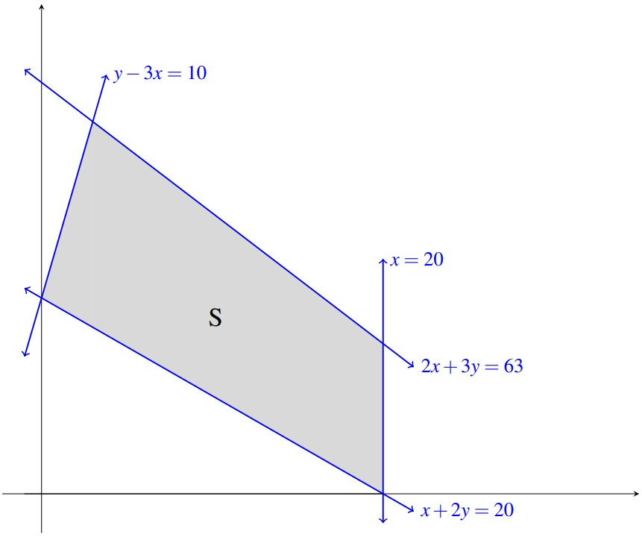
- Given the feasible set $S$, find the maximum of $P = x+4y$ using the method of corners.

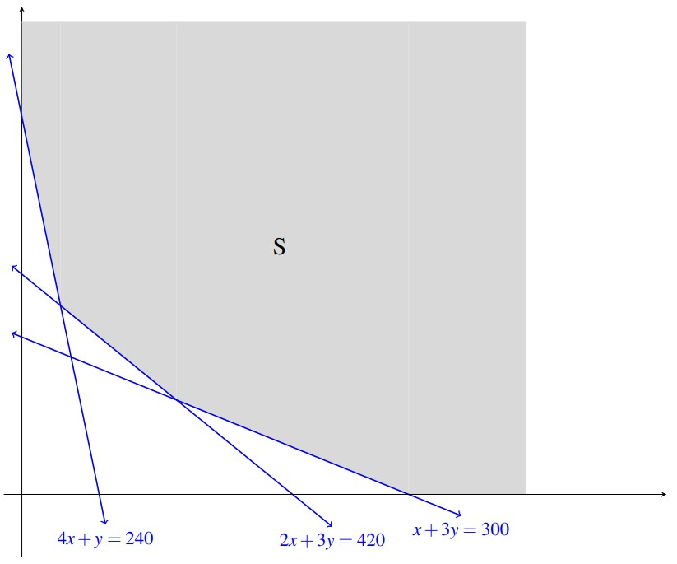

- A diet is to contain at least 2400 units of vitamins, 1800 units of minerals, and 1200 calories. Two foods, Food A and Food B are to be purchased. Each unit of Food A provides 50 units of vitamins, 30 units of minerals, and 10 calories. Each unit of Food B provides 20 units of vitamins, 20 units of minerals, and 40 calories. Food A costs $2 per unit and Food B cost $1 per unit. How many units of each food should be purchased to keep costs at a minimum?
  - Define the variables:

  - Objective:

  - Subject to:

