MATH 1324 – FINITE MATHEMATICS

SECTION 4.1 MATHEMATICAL EXPERIMENTS
- An experiment is an activity with observable results.
- A random experiment is an activity or an observation whose results cannot be predicted ahead of time. The following are random experiments:
  - Tossing a coin and observing if it is heads or tails
  - Casting a die and observing the number on top
  - Testing a spark plug from a batch of 100 and observing whether or not it is defective.
- The results of experiments are called outcomes or sample points.
- A sample space is the set consisting of all possible outcomes of the experiment. Denoted by $S$
- An event is a subset of the sample space (a collection of outcomes from an experiment).
  - NOTE: $2^{\# of outcomes} = total \# of possible events$
- An event which consists of exactly one outcome is called a simple event of the experiment.
- An impossible event is an event containing no outcomes. Denoted by $∅$ or $\{\}$

- For the experiment of tossing a coin and observing heads or tails, list the outcomes, the sample space, and the events.
  - Outcomes:

  - Sample space:

  - Events:

- NOTE: Unless stated otherwise, when we say die, we are referring to a standard six-sided die.

- Experiment: Roll a fair die and observe the number on top. Give the sample space and simple events.
  - $S =$

  - Simple events:

- Experiment: A card is selected at random from a standard 52 card deck, and its suit (hearts, diamonds, spades, clubs) is recorded. Give the sample space and simple events.
  - $S =$

  - Simple events:

Intersection of events $E$ and $F$:
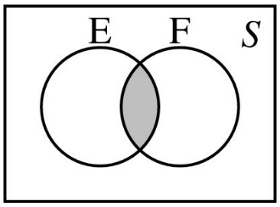
The event that contains all outcomes in both $E$ and $F$.
$E∩F=\{x|x∈E and x∈F$}

Union of events $E$ and $F$:
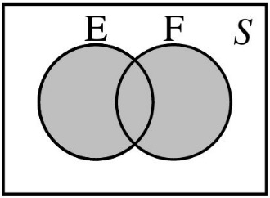
The event that contains all outcomes that belong to either $E$ or $F$ or both.
$E∪F=\{x|x∈E, x∈F, and x∈E∩F$}

Complement of event $E$:
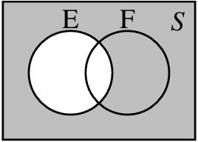
The event that contains all outcomes in $S$ but not in $E$.
$E^{c}=\{x|x∈S and x∉E$}

Mutually exclusive:
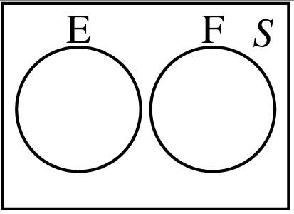
Events $E$ and $F$ have no outcomes in common.
$E∩F=∅$

- Let $S =\{1,2,3,4,5,6\}$, $E=\{2,4,6\}$, $F=\{1,3,5\}$, and $G=\{5,6$}. Find the event ${\left(E∩F∩G\right)}^{c}$.

- Suppose our experiment is to flip a fair coin 3 times. Give $S$

  - Find the event $E =\{x|x has exactly one head\}$

  - Find the event F$=\{x|x has two or more heads\}$

  - Find the event G$=\{x|x has more than three heads\}$

- Experiment: Roll a six-sided die. Give the sample space: $S =\{1,2,3,4,5,6\}$

- Experiment: Roll a pair of six-sided dice. Give the sample space.

  - Find the event $E=\left\{the sum is 8\right\}$

  - Find the event $F =${ one die is a 2}

  - Find the event $G=\{one die is at least a 5\}$

  - Find the event $H=\{the sum is 7 or one die is a 4\}$

  - Find the event $J =\{the sum is 7 and one die is a 4\}$

