MATH 1324– FINITE MATHEMATICS

SECTION 4.3 RULES OF PROBABILITY
- Properties of the Probability Function
  - $0≤P\left(E\right)≤1$ for any event $E$
  - $P(S) =1$ and $P(∅)=0$
  - Addition Rule (Union Rule): $P\left(E∪F\right)= P\left(E\right)+P\left(F\right)-P(E∩F)$
  - Rule of Complements: $P\left(E^{c}\right)= 1-P\left(E\right)$

- A pair of dice is cast and the number that appears uppermost is observed. What is the probability that

  - the sum is at least 3?

  - one die is a 4?

  - the first die is a 5?
The first number represents the outcome of the first die, and the second number represents the outcome of the second die.
$$S=\left\{\begin{aligned}11, 12, 13, 14, 15, 16, \\ 21, 22, 23, 24, 25, 26, \\ 31, 32, 33, 34, 35, 36, \\ 41, 42, 43, 44, 45, 46, \\ 51, 52, 53, 54, 55, 56, \\ 61, 62, 63, 64, 65, 66\end{aligned}\right\}$$

- An experiment consists of selecting a card at random from a standard 52 card deck. What is the probability that a king or a diamond is drawn?
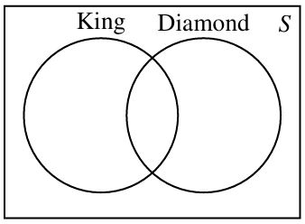
- Let $E$ and $F$ be two events of an experiment with sample space $S$. Suppose $P(E) = 0.6, P(F) = 0.4$, and $P(E∩F)=0.2$. Compute

- $P\left(E∪F\right)=$

- $P\left(E^{c}\right)=$

- $P\left(E^{c}∩F\right)=$
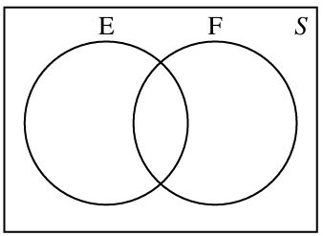

- Among 500 freshmen pursuing a business degree at a university, 320 are enrolled in an economics course, 225 are enrolled in a mathematics course, and 140 are enrolled in both an economics and a math course. What is the probability that a freshman selected at random from this group is enrolled in

- an economics or a math course?

- exactly one of these courses?

- neither of these courses?
