MATH 1324 – FINITE MATHEMATICS

SECTION 4.4 PROBABILITY DISTRIBUTIONS AND EXPECTED VALUE
- A random variable is a rule that assigns a number to each outcome of a chance experiment.
- A probability distribution is used to organize the values of a random variable and their corresponding probabilities.
- Experiment: Roll a six-sided fair die. Let $X$ denote the number that lands uppermost (is the number on top). RECALL: $S = \{1,2,3,4,5,6\}$

  - $X=1$ means $1$ lands uppermost
  - $X=2$ means $2$ lands uppermost
  - $X=6$ means $6$ lands uppermost

- Experiment: Draw three cards from a standard 52 card deck. Let $X$ denote the number of spades in the hand. Values for $X$: $X = 0, X = 1, X = 2, X = 3$

- Experiment: Toss a fair coin three times. Let $X$ denote the number of tails landing on top.
- Give the sample space of $X$ (i.e. the outcomes of the experiment).
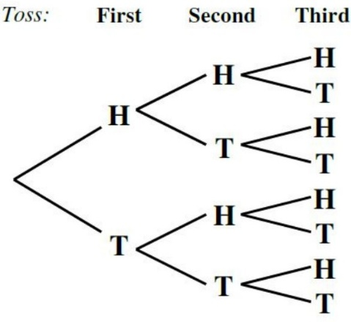
RECALL: $S = \{HHH,HHT,HTH,HTT,THH,THT,TTH,TTT\}$
- Find the value assigned to each outcome of the experiment by random variable $X$.
Outcome | HHH | HHT | HTH | HTT | THH | THT | TTH | TTT
Value of $X$:
- Find the event comprising the outcomes to which a value of $1$ has been assigned by $X$.

- Find the probability distribution.
$$X$$ | $$0$$ | $$1$$ | $$2$$ | $$3$$
$$P(X)$$
- What is the probability of obtaining no more than two tails?

- Draw a histogram for the probability distribution.
y-axis height | 0 | 1 | 2 | 3
$$\frac{3}{8}$$
$$\frac{2}{8}$$
$$\frac{1}{8}$$
 | 0 | 1 | 2 | 3

- Constructing a Histogram: A histogram is drawn in the first and second quadrants of the coordinate plane.
  - All axes must be labeled.
  - The $x$-axis is a number line representing the values of the random variable, $X$.
  - The $y$-axis represents probability and should be labeled $0$ to $1$ for the discussions in this book. Note: If the probabilities were given as percentages, the $y$-axis would be labeled $0\%$ to $100\%$.
  - A rectangle is constructed at each random variable value, with the height corresponding to the probability of the random variable value occurring, and the width being one unit. The value of the random variable should be placed at the center of the width.
- Let $X$ denote a random variable that assumes the values $x_{1}, x_{2}, x_{3},…, x_{n}$ with associated probabilities $p_{1}, p_{2}, p_{3},…, p_{n}$, respectively. Then the expected value of $X$, denoted by $E(X)$, is

- NOTE: The values $x_{1}, x_{2}, x_{3},…, x_{n}$ with may be positive, zero, or negative. For example, if the number represents a profit, it would be positive. If it represents a loss, it would be negative.

- Experiment: Roll a pair of fair six-sided dice. Let $X$ denote the sum of the faces that land uppermost.
- Find the probability distribution of $X$.
$$X$$ | $$0$$ | $$1$$ | $$2$$ | $$3$$ | 4 | 5 | 6 | 7 | 8 | 9 | 10 | 11 | 12
$$P(X)$$

The first number represents the outcome of the first die, and the second number represents the outcome of the second die.
$$S=\left\{\begin{aligned}11, 12, 13, 14, 15, 16, \\ 21, 22, 23, 24, 25, 26, \\ 31, 32, 33, 34, 35, 36, \\ 41, 42, 43, 44, 45, 46, \\ 51, 52, 53, 54, 55, 56, \\ 61, 62, 63, 64, 65, 66\end{aligned}\right\}$$

- What is the probability that the sum is more than $9$?

- What is the probability that the sum is between $4$ and $7$, inclusive?

- Draw a histogram for the probability distribution.
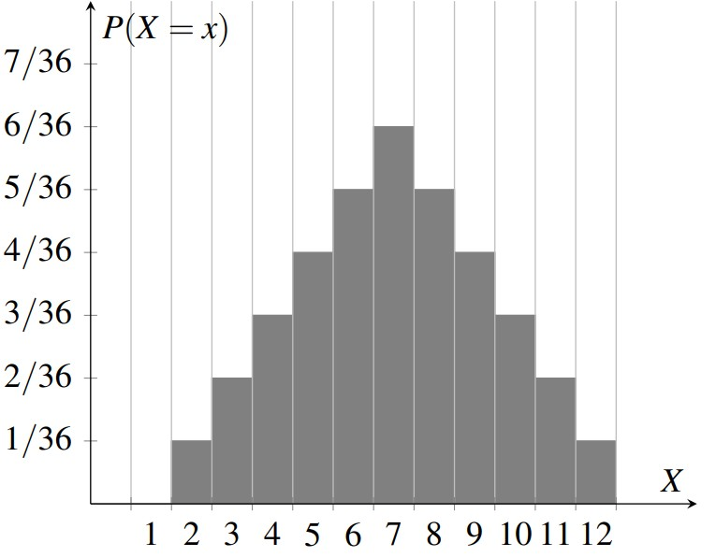
- Find the expected sum when the rolling the pair of dice.

- Geometric explanations:
  - Look at the histogram of a probability distribution associated with a random variable $X$. The expected value (mean) of $X$ is the balance point.
  - The mode is the tallest rectangle.
  - The median is where the area is cut in half.

- A sample of chocolate chip cookies was selected and the number of chocolate chips in each cookie was counted. The results are shown in the table below.
# of chocolate chips | 1 | 2 | 3 | 4 | 5 | 6
# of cookies | 2 | 2 | 4 | 6 | 2 | 4
- Determine the appropriate random variable $X$.

- Find the probability distribution for the experiment.
$$X$$ | $$1$$ | $$2$$ | $$3$$ | 4 | 5 | 6
$$P(X)$$
- Display the data in a probability histogram.

y-axis height | 1 | 2 | 3 | 4 | 5 | 6
$$\frac{10}{20}$$
$$\frac{8}{20}$$
$$\frac{6}{20}$$
$$\frac{4}{20}$$
$$\frac{2}{20}$$
 | 1 | 2 | 3 | 4 | 5 | 6

- Find the expected value of $X$.

- Find the mean of $X$.

- Which value of $X$ occurred the most?
- Which value of $X$ was in the middle?

- A real estate investor buys a parcel of land for $150,000. He estimates the probability that he can sell the land for $200,000 to be 0.40, the probability that he can sell it for $160,000 to be 0.45, and the probability that he can sell it for $125,000 to be 0.15. What is the expected profit from the sale of this land?

- Expected value is very common in making insurance decisions.
- The premium is what a person pays to obtain an insurance policy (the insurance company’s revenue).
- The insurance company can only afford to offer policies if they, on average, expect to make money on each policy. They can afford to pay out the occasional benefit, because they offer enough policies that those benefit payouts are balanced by the rest of the insured people who do not receive a payout.
- For people buying insurance, there is then a corresponding negative expected value. However, people still purchase insurance policies, as there is a security that comes from insurance that is worth the cost.
- The lowest premium a policy will be sold for is the one in which the company’s expected profit is $0.

- An insurance company estimates the probability of an earthquake in the next year to be 0.0013. The average damage done by an earthquake is estimated by the insurance company to be $60,000.
  - If the premium for earthquake insurance is $100, what is the company’s expected profit from the sale of the policy?

  - What is the minimum the company will sell the earthquake policy for?

- A mathematical ‘game’ (money is paid to play) is fair if the expected profit for both sides is 0.

- Jeb and Jimmy are playing a game using a pair of fair 6-sided dice. Jeb rolls the dice and Jimmy pays Jeb $1 if the sum of the dice is 5 or 6, $A if the sum is 8; otherwise Jeb pays Jimmy $2. Determine the value of A if the game is to be fair.

The first number represents the outcome of the first die, and the second number represents the outcome of the second die.
$$S=\left\{\begin{aligned}11, 12, 13, 14, 15, 16, \\ 21, 22, 23, 24, 25, 26, \\ 31, 32, 33, 34, 35, 36, \\ 41, 42, 43, 44, 45, 46, \\ 51, 52, 53, 54, 55, 56, \\ 61, 62, 63, 64, 65, 66\end{aligned}\right\}$$

