MATH 1324 – FINITE MATHEMATICS

SECTION 5.1-5.3 FUNCTIONS/POLYNOMIAL FUNCTIONS/RATIONAL FUNCTIONS
- A quadratic function is a second-degree polynomial function in one variable. Looks like
Form | Vertex | Axis of Symmetry | If $a>0$ | If $a<0$
$$f\left(x\right)=ax^{2}+bx+c$$ | $$\left(-\frac{b}{2a},f\left(-\frac{b}{2a}\right)\right)$$ | $$x=-\frac{b}{2a}$$
$$f\left(x\right)=a{\left(x-h\right)}^{2}+k$$ | $$\left(h,k\right)$$ | $$x=h$$

- https://www.desmos.com/calculator/pee6cqvgvk
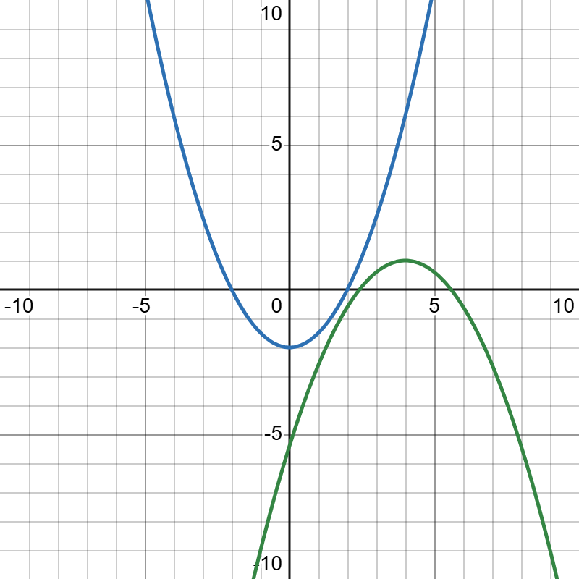
- RECALL: We can write revenue as $R\left(x\right)=px$ if the item being sold had a fixed selling price, $p$. Also the selling price of an item could be $p\left(x\right)=mx+b$, (linear price-demand function).
- $⋆⋆$If you are given $p(x)$, then the revenue function is given by $R\left(x\right)=p⋅x=\left(mx+b\right)x=mx^{2}+bx$. $⋆⋆$

- The total cost, in dollars, to produce $x$ “Math is Awesome” T-shirts is $C(x) = 2x+26$ for $x ≥ 0$. The price-demand function, in dollars per shirt, is given by $p(x) = 30-2x$; for $0 ≤ x ≤ 15$.
  - Find the revenue function, $R(x)$.

  - Find the profit function, $P(x)$.

  - Sketch $C(x),R(x),P(x)$. Label the axes.

  - Find the number of T-shirts which need to be sold in order to maximize profit.

  - Find the maximum profit.

  - Find the price to charge per T-shirt, in order to maximize profit.

  - Interpret the break-even quantity/quantities, if any exist.

- Revisiting a previous example (from Section 2.2): A company makes rollerblades. When the unit price is $180, quantity demanded is 10 pairs. Quantity demanded is 50 pairs when the price is $100. The company is not willing to sell rollerblades for $60 or less per pair. It will supply 10 pairs if it can get $80 a pair.
- RECALL FROM 2.2: $D(x) = -2x+200$ and $S(x) = 2x+60$

- Find the revenue function, $R(x)$.

- How many pairs of rollerblades should be sold to maximize revenue? What is the maximum revenue?

- At what price should pairs of rollerblades be sold in order to maximize revenue?

- If the total cost is $C(x)$, then the average cost function is $\overline{C}\left(x\right)=\frac{C\left(x\right)}{x}$, which is the average cost per item for $x$ items produced.
- The average cost function is a rational function, which is a polynomial divided by a polynomial.

- If the total cost function for a commodity is $C\left(x\right)=0.1x^{2}+50x+90$, where $x$ gives the number of items produced,
  - find the average cost, $\overline{C}$.

  - find the minimum average cost.

