MATH 1324 – FINITE MATHEMATICS

SECTION 5.6-5.8 EXPONENTIAL & LOGARITHMIC FUNCTIONS/TRANSFORMATIONS
- Graph

  - $f\left(x\right)=2^{x}$
  - $g\left(x\right)={\left(\frac{1}{2}\right)}^{x}$
  - $h\left(x\right)=e^{x}$

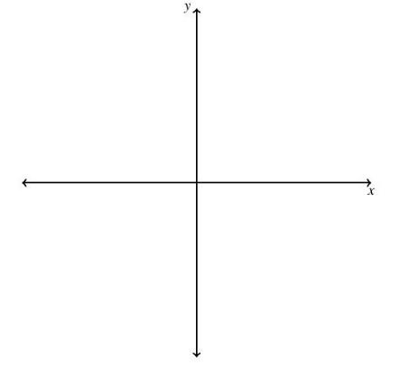
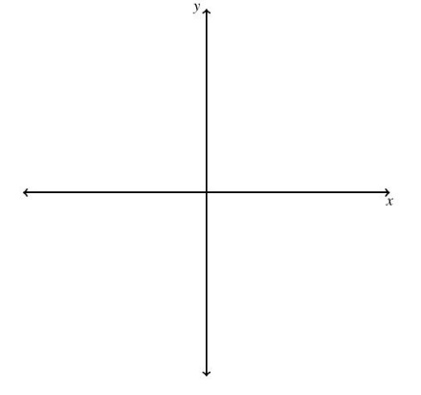
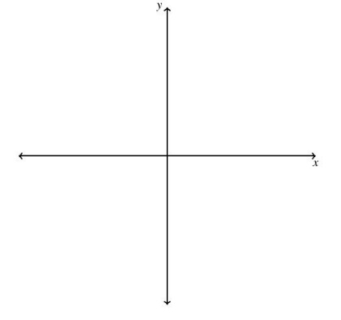

- If $b>1$: Growth
- If $0<b<1$: Decay

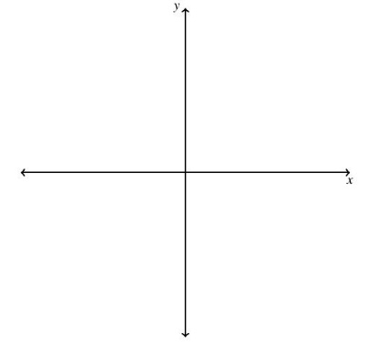
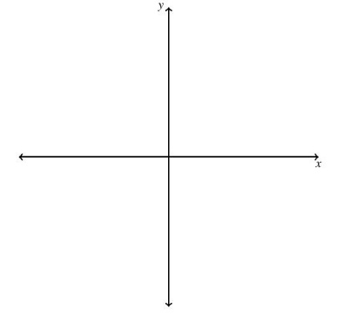
- We can also shift and reflect graphs of $f(x) = b^{x}$.
- Sketch $y = 2^{x}+2$ with the graph of $y = 2^{x}$
- $e ≈ 2.71812818284…$
- Exponential functions $(y=b^{x},b>0,b≠1)$ and logarithmic functions $(y=\log_{b}{x},b>0,b≠1)$ are inverses of each other.

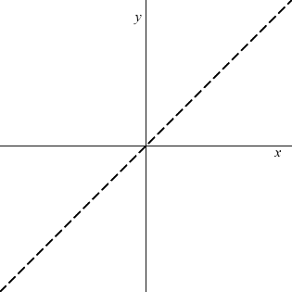

- $y=b^{x}$and $y=\log_{b}{x}$
- $b≠1, b>1$

- $y=b^{x}$and $y=\log_{b}{x}$
- $b≠1, 0<b<1$

- NOTE: $logx =\log_{10}{x}$ and $lnx =\log_{e}{x}$.
- Exponential and/or logarithmic functions, sometimes combined with polynomial or other functions, are often used to model behavior of real world phenomenon.
- Financial applications are modeled with exponentials functions. We will discuss those in Chapter 6.
- The sound intensity level, measured in decibels, is given by $β =10\log\left(\frac{I}{I_{0}}\right)$ where $I_{0}={10}^{-12}$ watts per square meter is the reference intensity and $I$, measured in watts per square meter, is the sound intensity.
  - If the sound intensity of a siren from a fire truck is 2 watts per square meter, find the sound intensity level $β$.

  - If the city fireworks show has sound intensity level of $β = 142$, find the sound intensity.

  - Compare sound intensities of 123 decibels to 142 decibels.

- A surge function can be used to represent the way a drug interacts in the bloodstream. Studying this function is essential to doctors and pharmacists because it allows them to administer dosages of medicine correctly. Consider this surge function giving concentration $C$ in the patient’s bloodstream, measured in ng/mL (nanograms per milliter), of a particular medication at time $t$, given in hours: $C(t) = 6.2t^{4}e^{-0.5t}$
Tarko, Olta (2021) “Surge Functions and Drug Interactions,” Undergraduate Journal of Mathematical Modeling: One + Two: Vol. 12: Iss. 1, Article 7. Available at: https://digitalcommons.usf.edu/ujmm/vol12/iss1/7
- Find the concentration of the medication after 90 minutes.

- Find the maximum concentration of the medication in the patient’s bloodstream. At what time is the concentration a maximum?

- If a second dose can be administered once the drug concentration has reached a minimum effectiveness of 50 ng/mL, when should a second dose be administered?

- NEWTON’S LAW OF COOLING: The temperature $T$ of an object at time $t$ is given by
$T(t) = T_{a}+ \left(T_{0}-T_{a}\right)e^{-kt}$ , where $T_{a}$ is the ambient temperature (temperature of the surroundings), $T_{0}$ is the initial temperature, and $k$ is an experimentally-determined constant. (NOTE: $k$ is different depending on the object. $k > 0$)

- Suppose a body has been discovered and homicide detectives have a suspect in custody. The suspect has an alibi after 7pm the previous night. At 7am, at the crime scene, the body temperature was ${84.3}^{∘}$ and the air temperature was${78}^{∘}$ . If the normal human body temperature is ${98.6}^{∘}$and $k = 0.1947$, does the alibi rule out the suspect?

